**LAB REPORT #8** Name: Owais Rao

**LOOPS & NESTED LOOPS** Roll No.:22L-7638

Class: BSEE-1A2

**Introduction:-**

 A nested loop is a loop in which**one loop resides inside another loop where the inner loop gets executed first,** satisfying all the set of conditions that prevailed within the loop followed by an outer loop set of conditions. Nested loops are also called as “loop inside loop“.**C++** allows at least 256 levels of nesting.

**Objective:-**

* To be able to understand the working of nested control structures.

**Procedure:-**

With the help of lab manual, I was able to write codes for given exercises. They are as follows with their outputs:-

**Exercise 1:-**

#include <iostream>

using namespace std;

void main()

{

int a, b, c, d;

c = 10;

for (a = 10; a > 0; a--)

{

for (b = 10; b <= c; b++)

{

cout << " ";

}

for (d = 1; d <= a; d++)

{

cout << "*";

}

cout << endl;

c++;

}

}

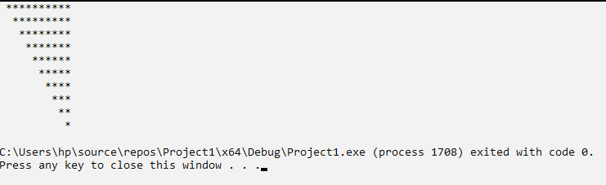

**Exercise 2:-**

#include <iostream>

using namespace std;

void main()

{

float factorial = 1;

float e = 1;

for (int f = 1; f < 10000; f++)

{

for (int g = 1; g <= f; g++)

{

factorial *= g;

}

e += (1.0 / (factorial));

factorial = 1;

}

cout << endl << " e = " << e << endl;

}

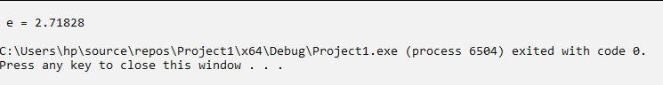

**Issues:-**

No issues were faced.

**Conclusion:-**

* I was able to understand the working of nested control structures.

**Applications:-**

* We can place control structures inside other control statements when more than one decision must be made4 before carrying out a task.
* To manipulate how we are displaying the outputs of the code visually on the debug console.

**Post Lab:-**

#include <iostream>

using namespace std;

void main()

{

float x, y, sum = 0, z;

for (int i = 1; i < 99; i++)

{

if (i % 2 != 0)

{

x = i;

y = i + 2;

z = x / y;

sum += z;

}

}

cout << endl << " Sum of the series: " << sum << endl;

}

